HappyNest Expectation for Return Bundles

Delivery photo example with folded bundles and hanging – this would be filled out as 3 bundles and 1 hanging in the production manifest: 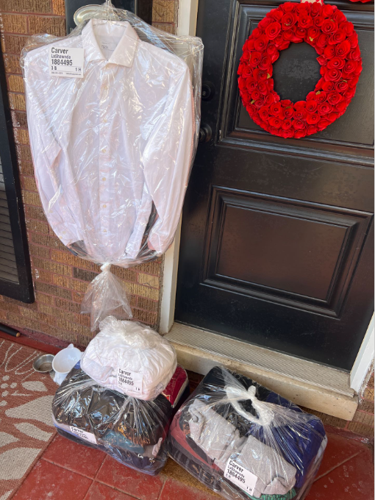

Examples of permanent HappyNest bags folded in with the rest of the customer’s returned laundry:

Figure 1: would be input as 4 bundles in the production manifest / “per bag” bags folded in first bundle on top
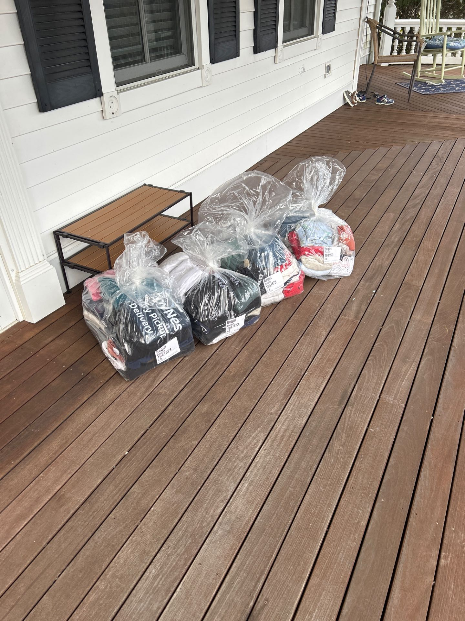
Figure 2: navy blue “per bag” bags shown folded in with the rest of the laundry
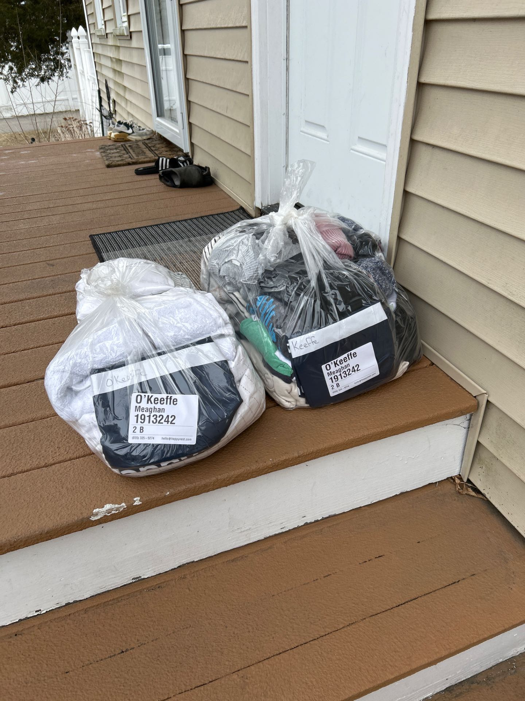
Examples of plastic HappyNest branded bags folded in with the rest of the customer’s returned laundry:

Example 2:
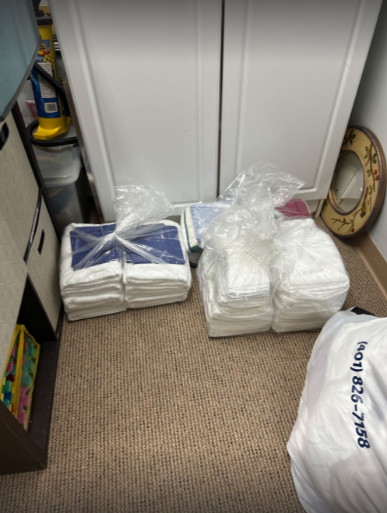

Example 3:
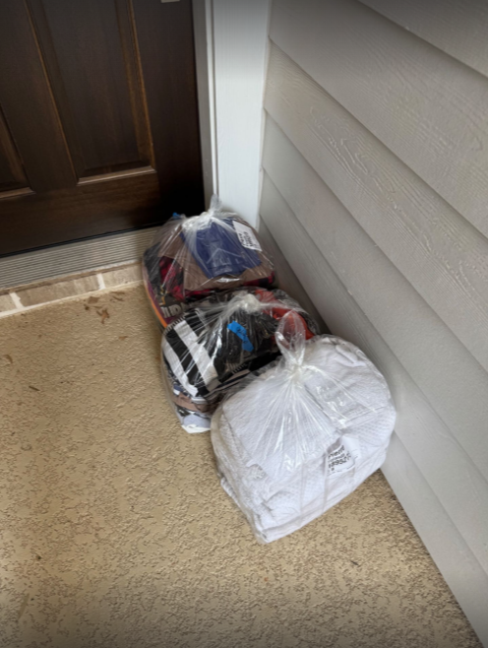
HappyNest bundles should be returned in clear plastic poly bags with the zebra printer label clearly stuck to the bag and front facing. For new customers, 2 plastic bags should be included inside the bundle folded on top of the laundry inside the clear plastic bag.

