How to Add a Sanitation Fee

- You must pre-authorize the customer before you can add any fees. 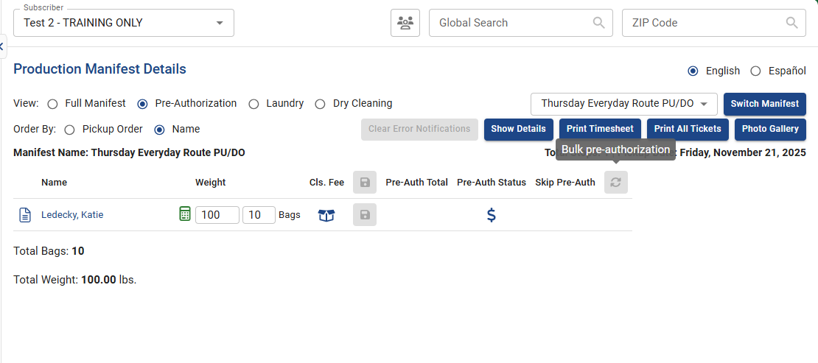
- Once they are pre-authorized, you will need to fill out the “loaded by” and “folded by” sections on the Laundry tab. 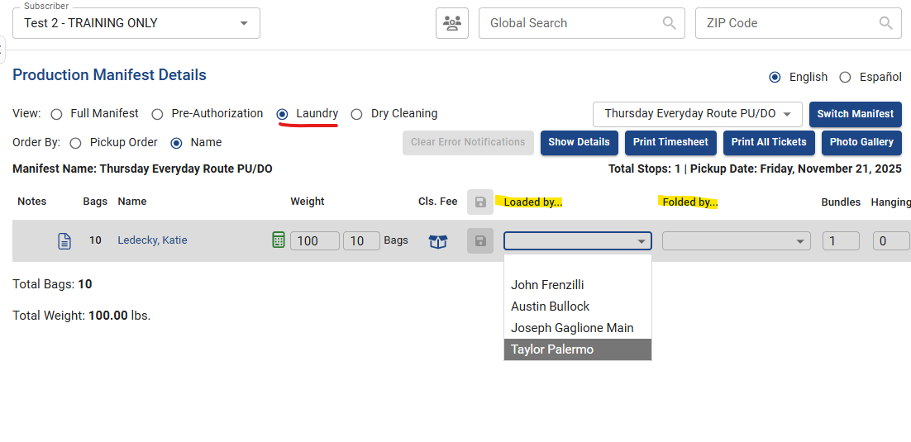
- Click the check box underneath “Bulk Wash” and press save. 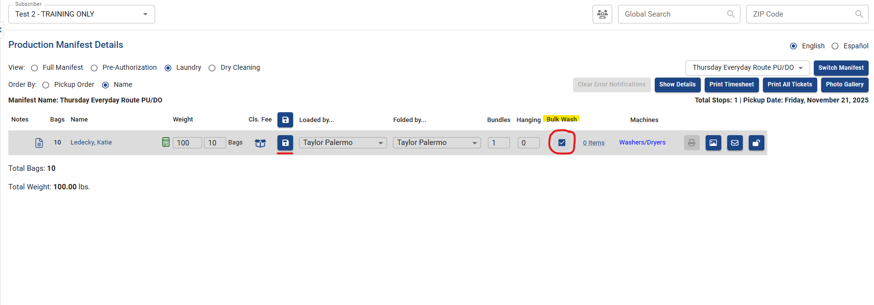
- Click “0 Items” and a list of fees will appear. Scroll down to “Miscellaneous Washable Items” and locate “Sanitation Fee” 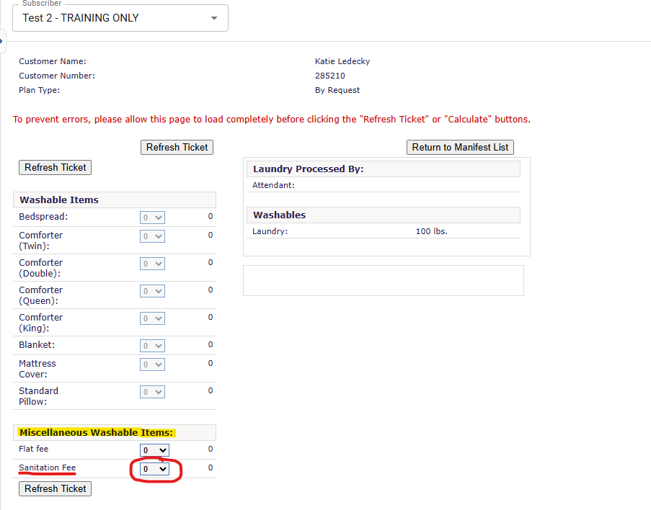
- Select “1” on the drop-down bar and click “Refresh Ticket” 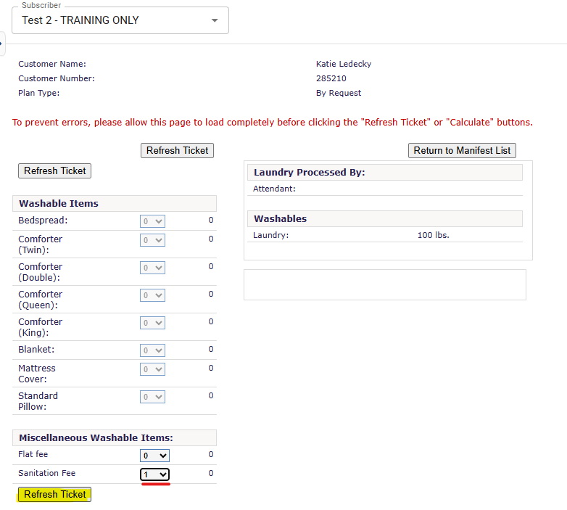

[Please note: this fee should ONLY be applied to items that are heavily soiled with bodily fluids such as urine, feces, vomit, etc. should you choose to still launder them. As a reminder, your team is under no obligation to launder these types of items as the health and safety of your staff is the priority. Please alert Customer Service if you are going to add this fee to an order so they can give the client notice of the additional charge.]
- When you see the Sanitation Fee applied on the right side of the screen underneath “Washable Items” you can then click “Return to Manifest”. 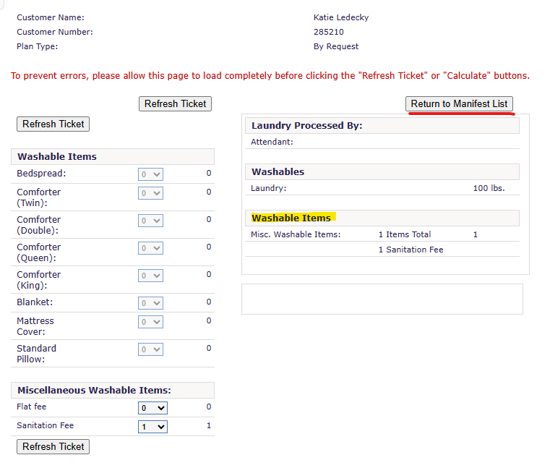
- You will know the fee has been applied when the area that previously said, “0 Items” now says “1 Items”. 