How to Add a Bag Closure Fee

- When you are in your production manifest you will fill out your weight, bags, bundles and hanging as normal. 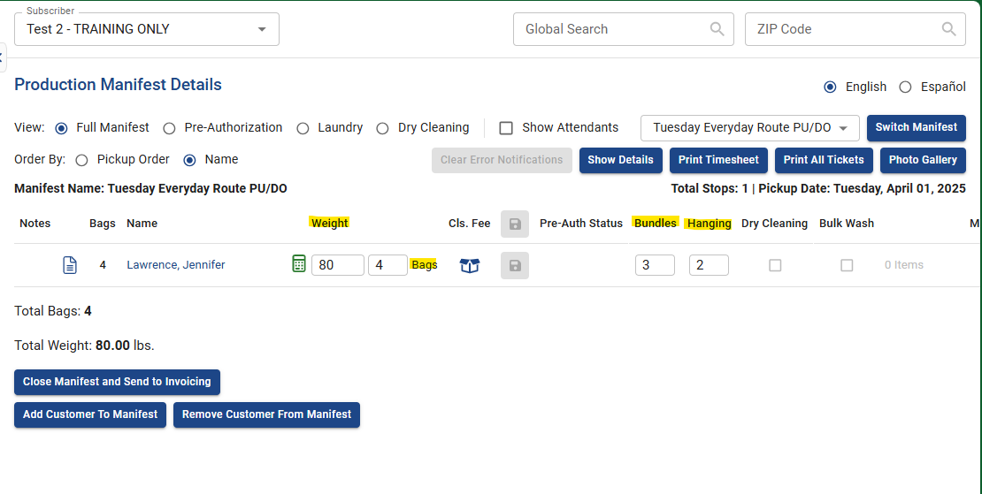
- Next, you will click the icon that looks like an open box underneath where it says “Cls. Fee” 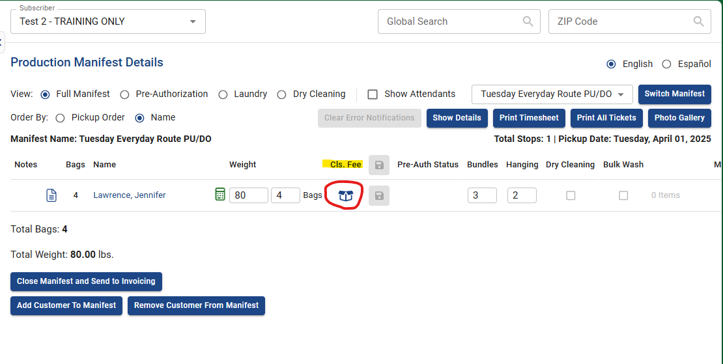This will add the $7.99 closure fee to the order. Only one bag closure fee can be added per customer’s order, not per bag. The bag closure fee is intended to be a disciplinary tool rather than a way to earn revenue.

If you feel you would have to charge a fee per each bag sent in, at that point you would charge an additional bag instead of multiple bag closure fees.

Here are some examples of how to charge certain orders:

- 2 bags + 1 bag closure fee: 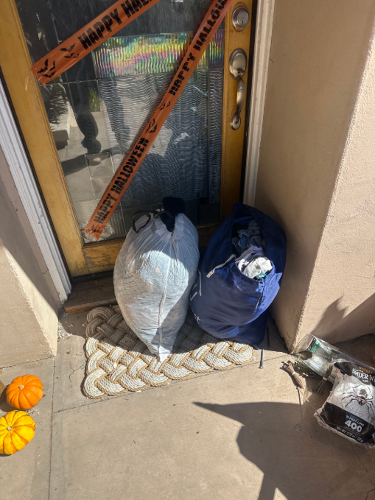
Reason: The bag on the right is completely unable to close, and items could fall out of this bag due to that.
- 6 bags: 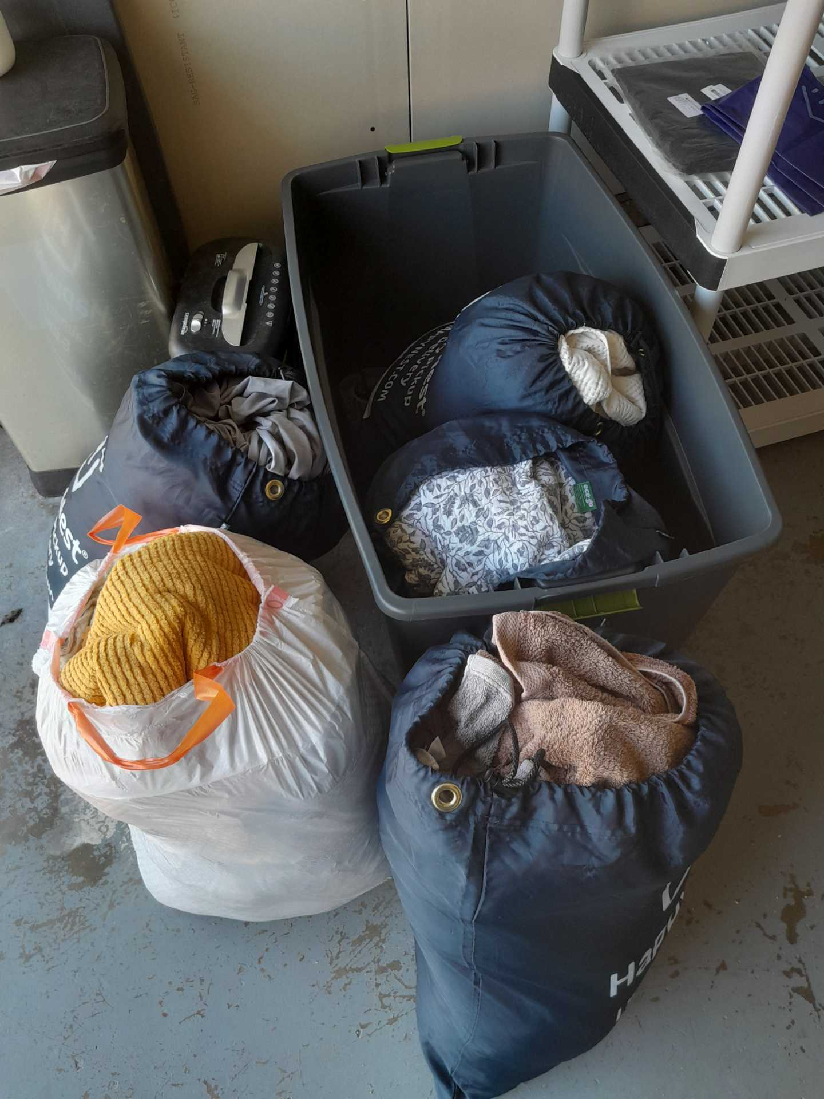

Reason: with all the clothing spilling out of each bag, you could easily fill another bag with the excess items. If you charged 5 bag closure fees here, that would essentially be another bag charge anyway!
PLEASE NOTE: A bag closure fee should only be applied to orders where the bag that is PICKED UP is open.

