Production Manifest Process

- When your driver closes out the route for the day, all customers who were picked up will end up on a production manifest for the day. This will be how you bill the customers for their laundry. Please log-in and clock-in to your role for the day (Admin, Attendant or Driver). Anyone can fill out the production manifest if the admin approves of it. Once you are logged in and clocked in – please press, “Manifests” and then, “Production Manifests” 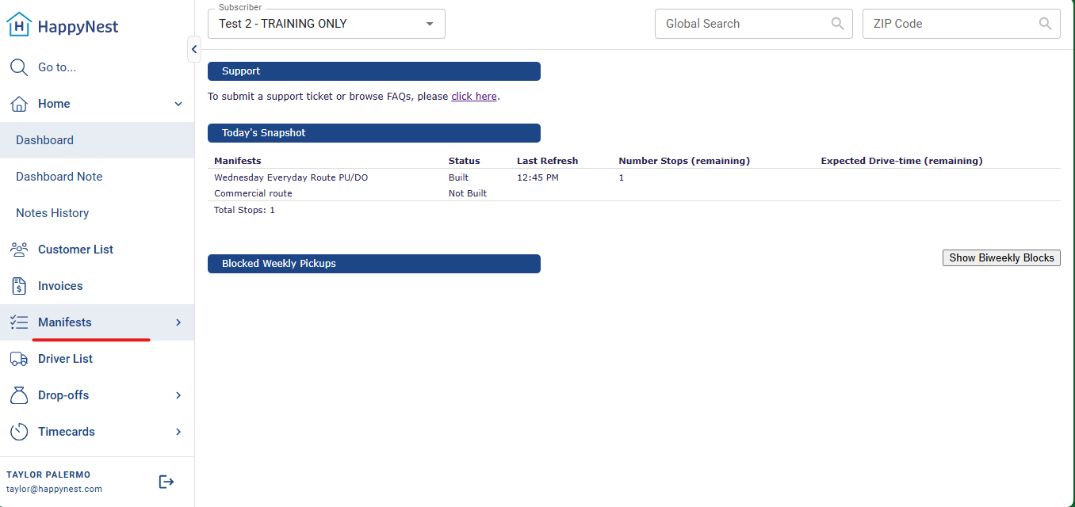
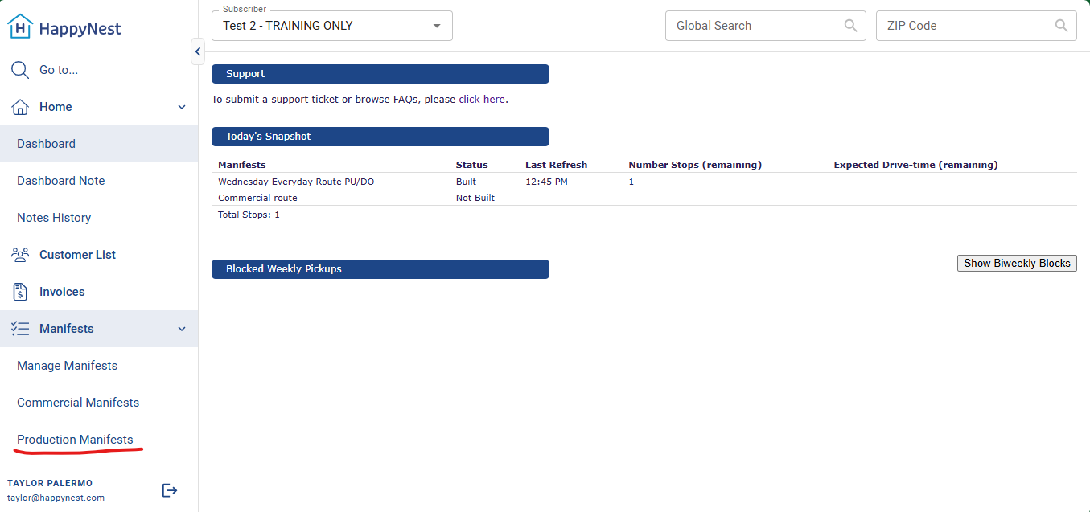
- This will then bring you to any open production manifests you have. It will detail the route name and date. When you are ready to start filling out the information, please press, “Details”. 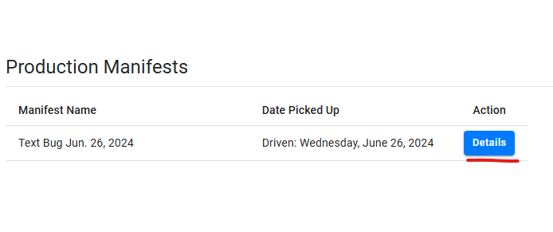
It will then take you to a page that looks like this: 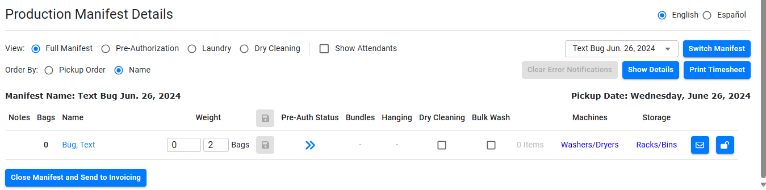
The box to the left of the word, “Bags” will already be filled out with the number of bags the driver put in as picked up through the driver app. This may not be accurate to the number of bags we will actually charge the customer, but I will detail that process a few steps from now.

- Whoever is processing the items can click on the icon to the left of the customer’s name (it looks like a piece of lined paper with the top right edge folded down) and that will pull up this page in a separate tab: 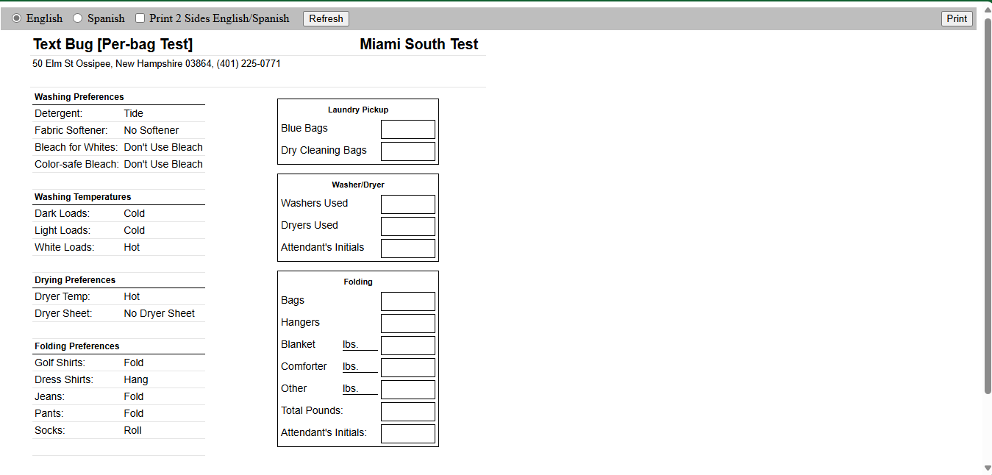
This shows the customers’ laundry preferences. You can print this page out in English, Spanish or a double-sided page that has English on one side and Spanish on the other side. This helps keep track of who worked on the order and ensures whoever is working on it is following the preferences on the account set by the customer.
- You can then go back to the tab you were in previously that shows, “Full Manifest”. Please make sure to weigh the bag(s) every time. Even if the customers are, “per bag” we still need to track the weight for: first time customers who don’t have our HappyNest bags yet, to track how much weight your facility is getting to map your growth within the company and to track any missing items cases should they arise.
- For first time customers, it will indicate “NEW” next to their name. New customers will be instructed to send in 13-gallon kitchen bags. As long as they send in a 13-gallon bag, you will count the bags they send in and charge according to how many bags were picked up.
- If a customer sends in a full bag bigger than 13-gallon, you will charge 2 bags per larger bag. Example: 3 bags bigger than 13-gallon = 6 bag charge.

- For the purposes of this training document – we will assume this is a new customer who sent in 2 trash bags full of items – one 13-gallon and one 40-gallon. Let’s say the total weight of their order was 70lbs. You will input that under the left box pictured below: 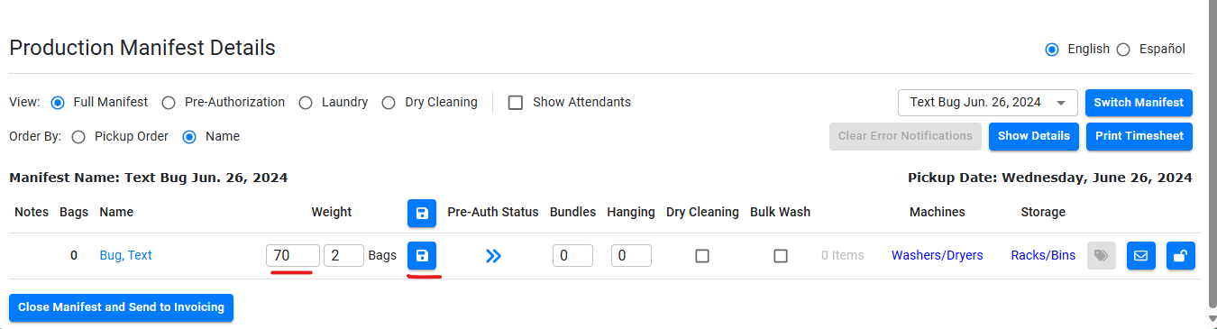
After you input anything in these boxes, the blue button with the white floppy disk icon will appear clickable. This is to save anything you input. It is essential to save after you input any information, otherwise it will not allow you to go any further through the process.
- This is where you will count the 13-gallon bag as 1 bag and then the 40-gallon bag as 2 bags. That will make this order 3 total HappyNest bags. You will then change the number in the box for “Bags” like so: 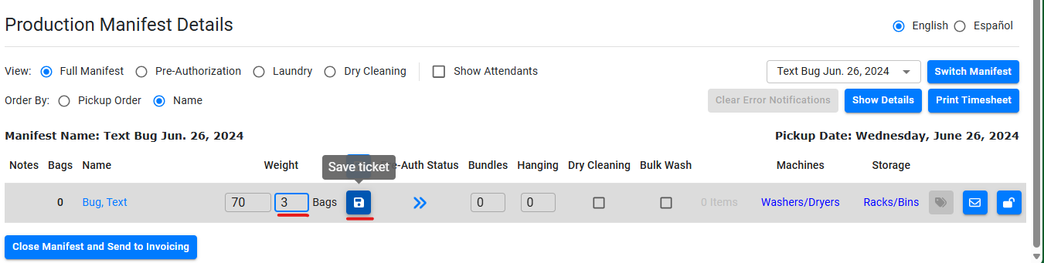
Even though we are tracking the weight for important purposes like growth, the way the customer is billed is solely based off of the number of bags that are input. So, this customer will be charged for 3 bags.
- Next, you will go up to, “Pre-Authorization”. My screen will look a bit different than what you will actually see – so I will detail what yours should look like: 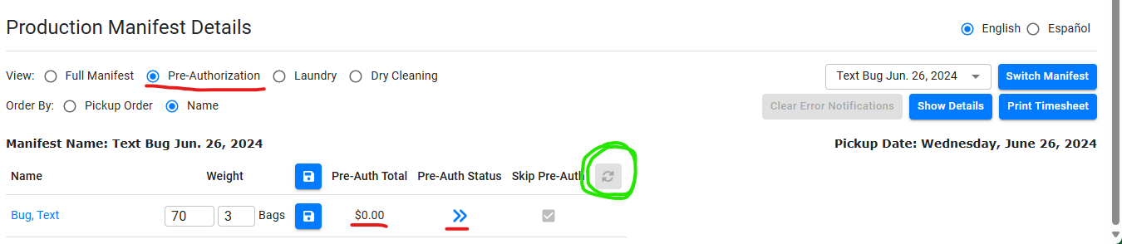
- Under where it says, “Pre-Auth Total” it will automatically calculate what the total of the order will be based on your per bag pricing. For example, if you are $32.95 per bag, the total will read “$98.85” in that field where it currently says, “$0.00”.
- Next, you will press the button I’ve circled in green. In your production manifest, that button will not be greyed out and will appear in blue and be clickable. This will initiate the process to place the pre-authorization hold on customer’s cards. The pre-authorization hold tends to be about $10 more than the actual invoice itself. It may take a minute or so to process the pre-authorizations.
- Finally, under “Pre-Auth Status” after each customer’s pre-auth has been processed, there will either be a blue thumbs up icon, or a blue X icon. Thumbs up indicates that the pre-authorization was successful, and the X indicates it failed.
- ON A SUCCESS: You can now start laundering the items!
- ON A FAILURE: You can still process the laundry, however, we advise you to please hold off on delivering the laundry until we get successful payment.
- You will now click on the “Laundry” tab and fill out who loaded the items into the washer and dryer and who folded the items. Please click the drop-down bar under, “Loaded by…” and “Folded by…” to select the name of the employee who worked on this order. 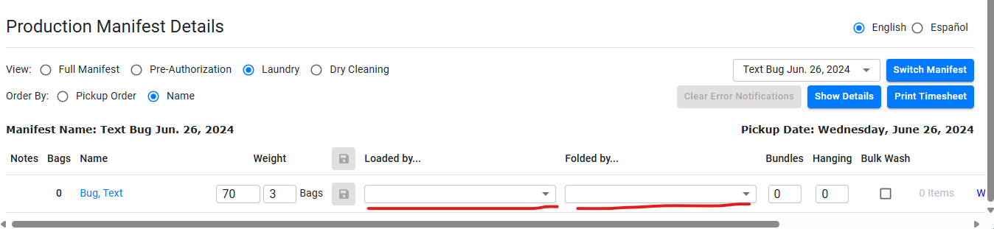
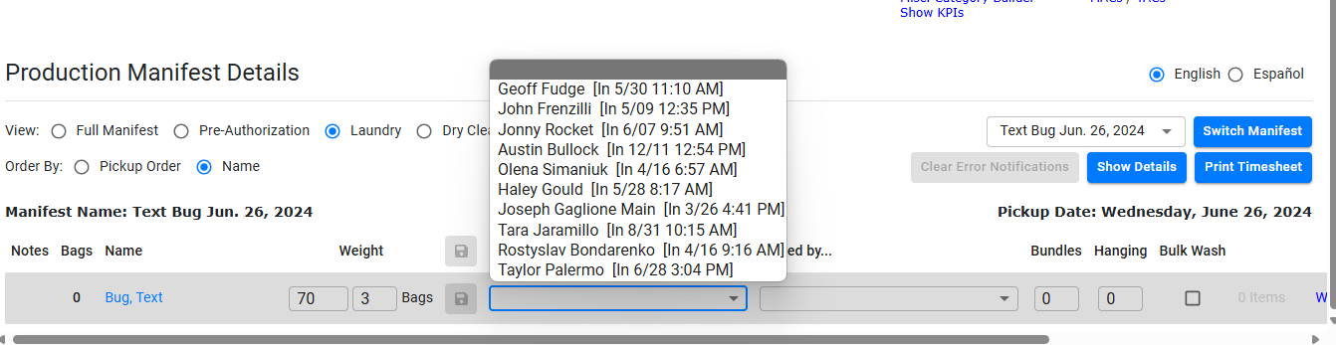
REMEMBER – once you select your name on the drop-down bar, please press save! 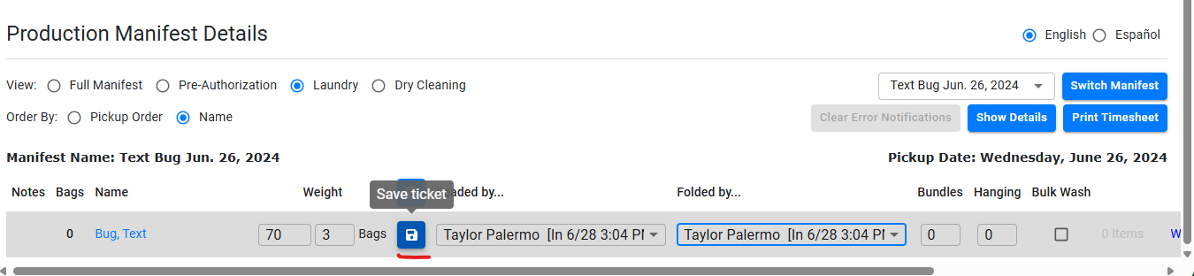
- You can then go back to “Full Manifest” and fill out the area that says, “Bundles” and “Hanging”. This step comes after the folding/hanging process once you figure out how many plastic bundles you are returning the clothing in. If you have 5 items on hangers, that would only be considered 1 “hanging”, not 5 “hanging”.
This is because the numbers in those boxes directly correspond to how many labels are being printed out from the Zebra Printer. So, instead of 10 labels being printed out for each individual hanging item, there would only be 2 labels printed out signifying 2 “hanging” bundles with 5 items in them each. The hanging bundles typically get banded together with plastic wrap placed over them, which is what you will place the label sticker on.
- Here is an example photo of “hanging” bundles: 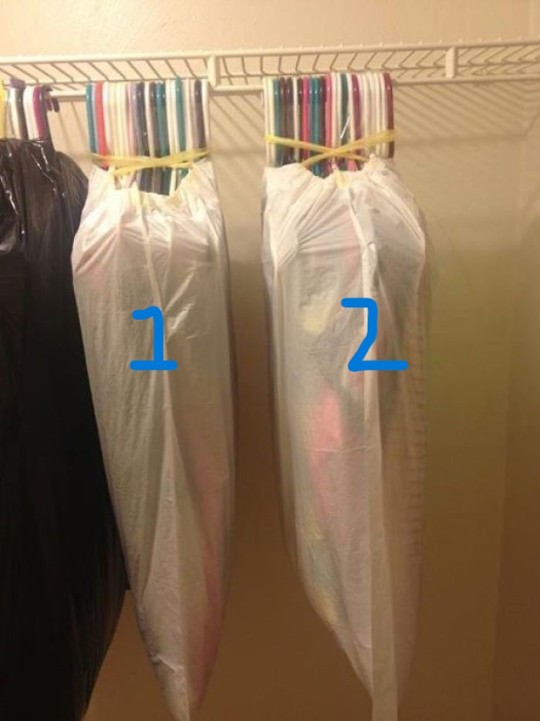
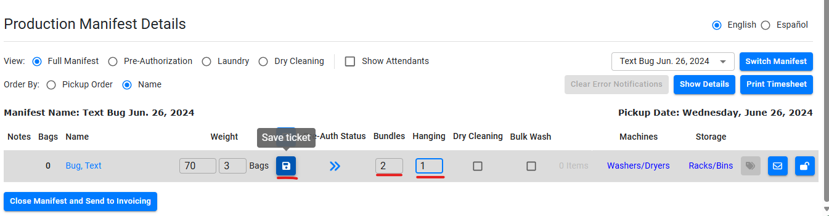
Once you input how many folded bundles and hanging bundles you have, the labels button will become blue and appear clickable. You will click on this, and your Zebra printer will print the number of labels needed based off of what you input. You can then stick these labels to the corresponding bundles. 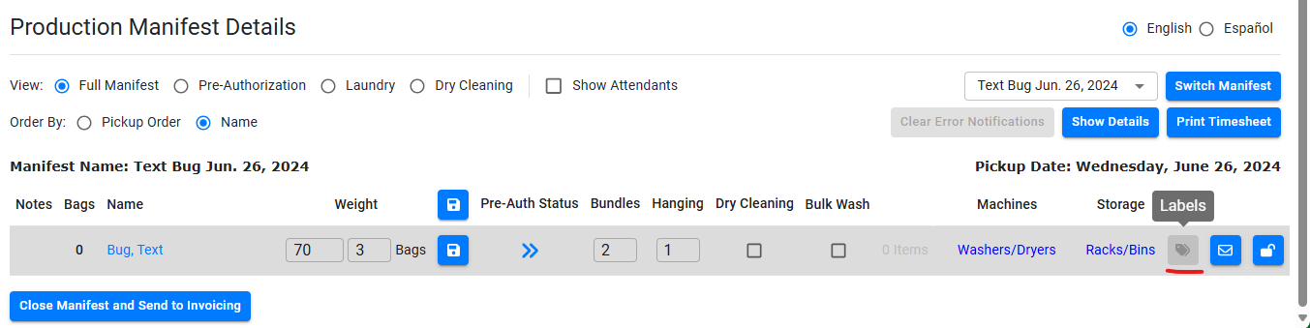
- When that is done, you can head back to “Full Manifest” once everything is filled out and press, “Close Manifest and Send to Invoicing”. 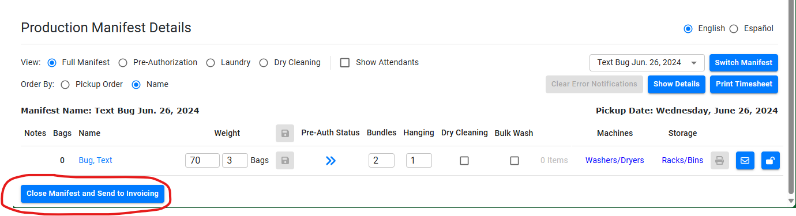
- This will prompt you to review any missed pickup/same day cancellations from the day so you can decide whether to charge the customer or not for it. 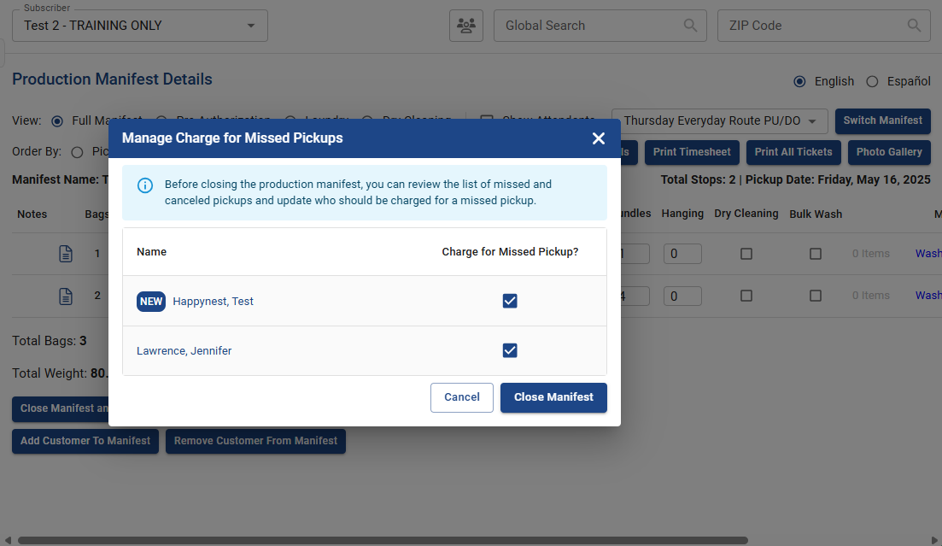
If you don’t want to charge the customer the fee, simply unclick the checkbox, then press “close manifest”. 