How to Create a User

- Go to, “Manage” on the left side bar and click on “User” 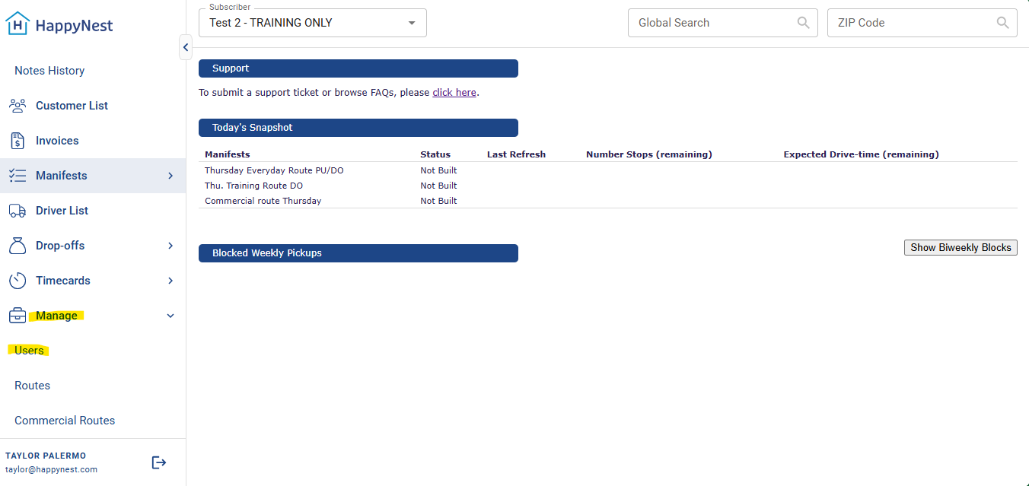
- Click, “Create New Admin” in the top right 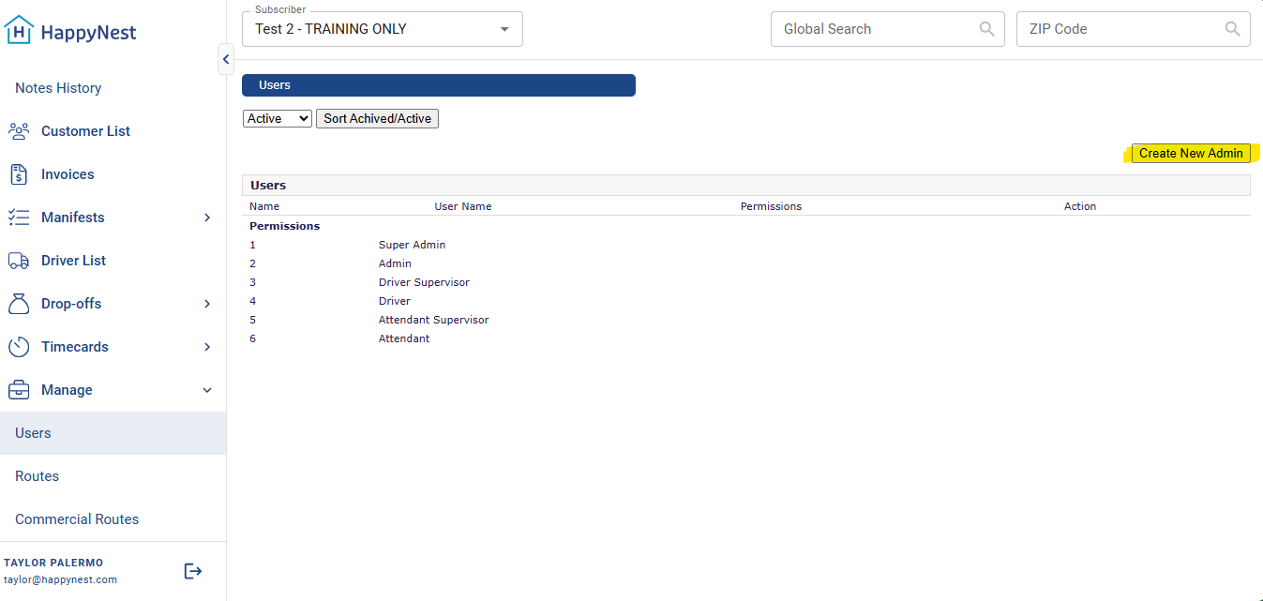
- Once you make it to this screen, the required parts to fill out are highlighted: 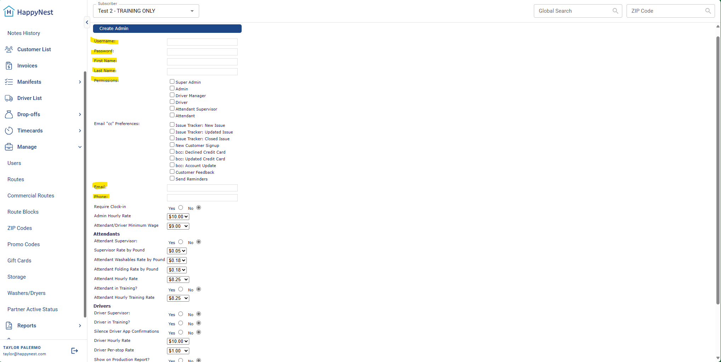
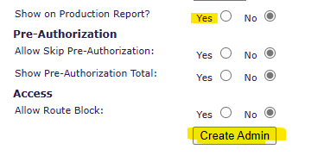

Things to note:
- The username is typically the person’s first name and last initial, like so: “John Doe” would be, “JohnD”
- Passwords are usually set as Laundry123 to start and the partner should change them once they teach the new employee how to log-in. The employee is encouraged to create and remember their own password.
- Every active employee needs to have their own user and cannot be sharing users.
- The section that says, “email cc preferences” dictates what system emails the partner receives from us. This should be filled out for Management at the facility only.
- Always switch, “show on production support” to “Yes” otherwise employees will not show up in any reports or on the dashboard.

