How to Access/Navigate Driver Tipping Report

- On the left sidebar scroll down to and click on “Reports” then “Reports” again underneath the first one. 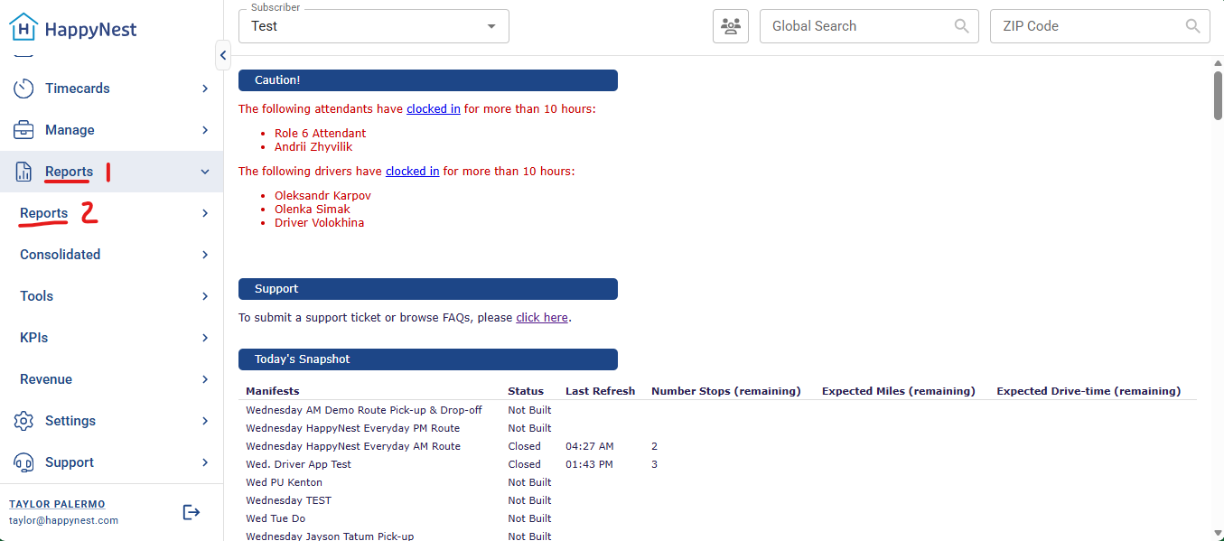
- Scroll down and click “Driver Tipping” 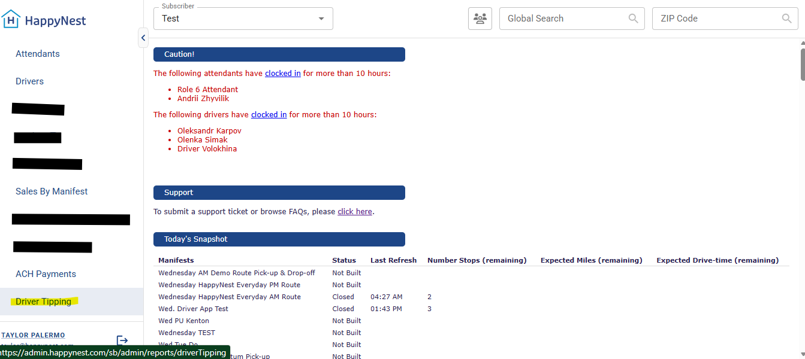
- Click “Driver Tips By Manifest” 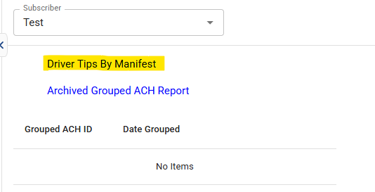
- Select the driver and date range then press “Search” 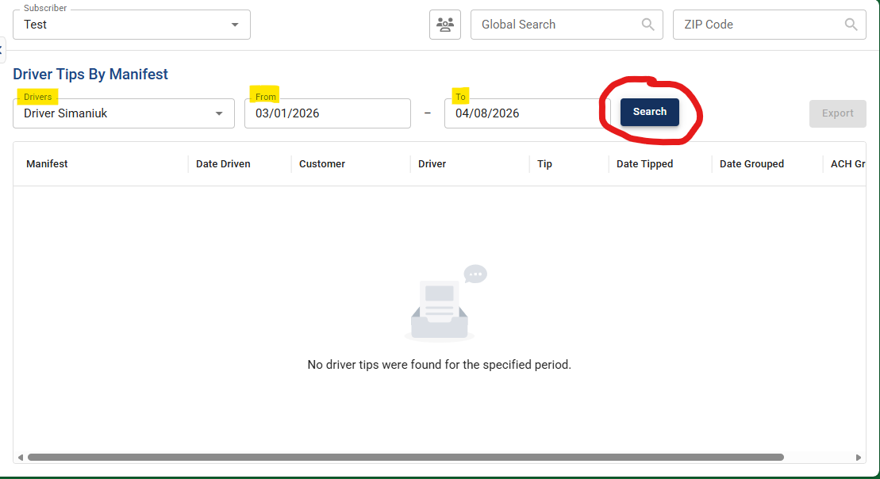
- You can review all information on this screen or export it to an excel sheet if needed. 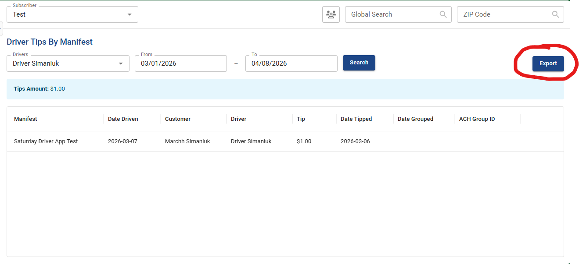

Things to note:
- Some partners pay out tips weekly; some do it monthly
- Some partners pool all tips and split them between drivers AND processors
- Some partners pool them and use the excess money as bonus incentives
- Some partners do not pay out tips to drivers and keep the excess themselves

