How to Access Driver & Attendant Reports

- On the left sidebar scroll down to and click “Reports” then “Reports” again underneath that. 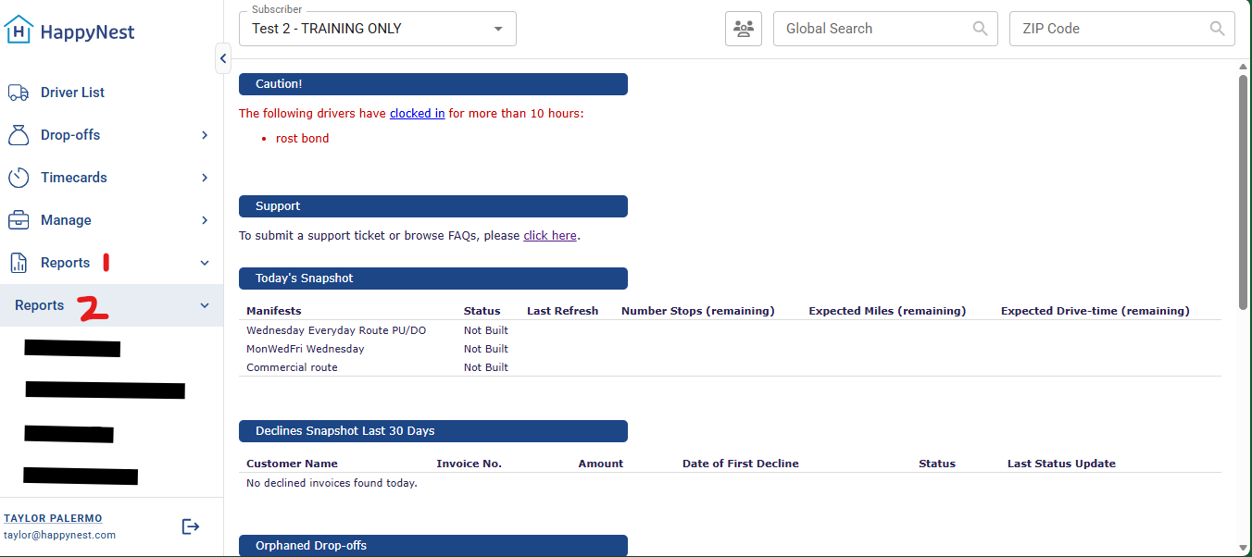
- Click “Attendants” or “Drivers” depending on which employees you want to see information for. 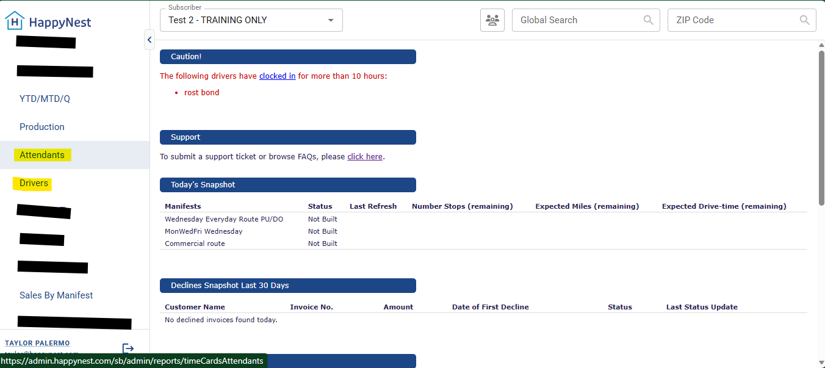
- For Attendant: select date (shows per week) then click “Refresh Results” 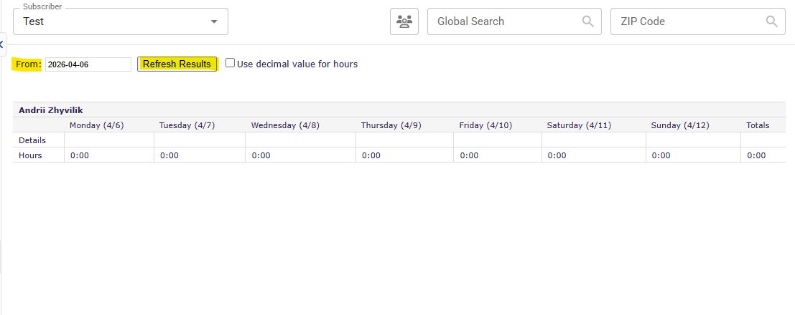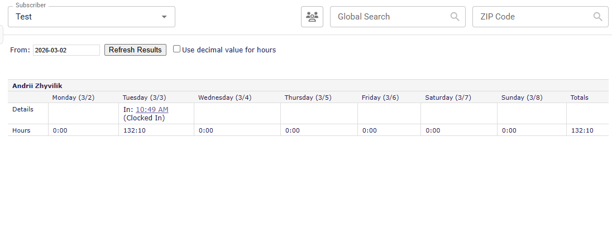
This will show you their timecard per each week if you are tracking their hours through Springboard.

- For Drivers: select date (shows per week) then click “Refresh Results” 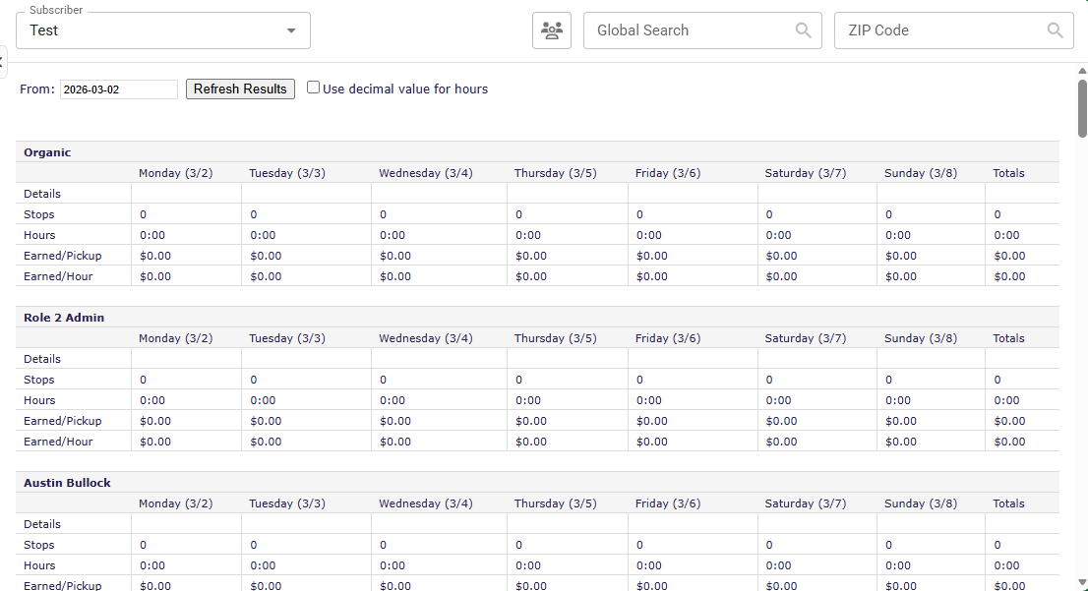

You can also see amounts earned per pickup or per hour depending on how you set their User up in Springboard. Please see example below:
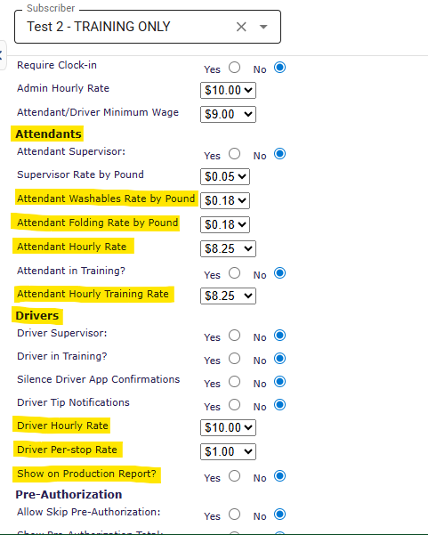
Whatever information you enter in these categories during User setup process will appear in the Driver/Attendant/Production reports on Springboard.

