How to Access Sales by Manifest Report

- On the left sidebar, scroll down to and click on “Reports”, then click “Reports” again underneath it. 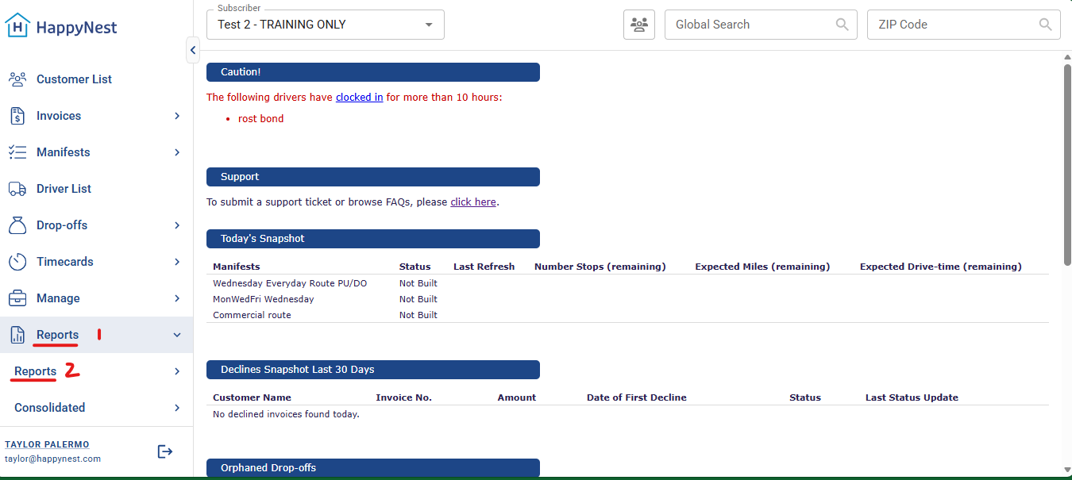
- Scroll down and click on “Sales By Manifest” 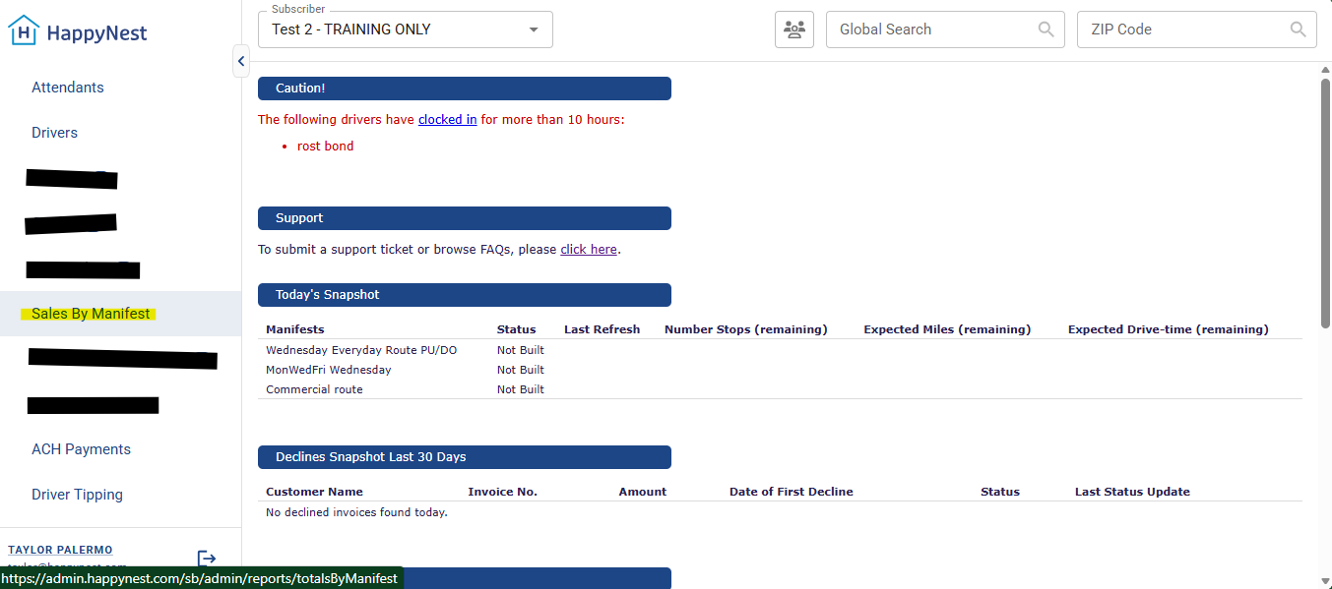
- Choose the date range you need and click “Search” 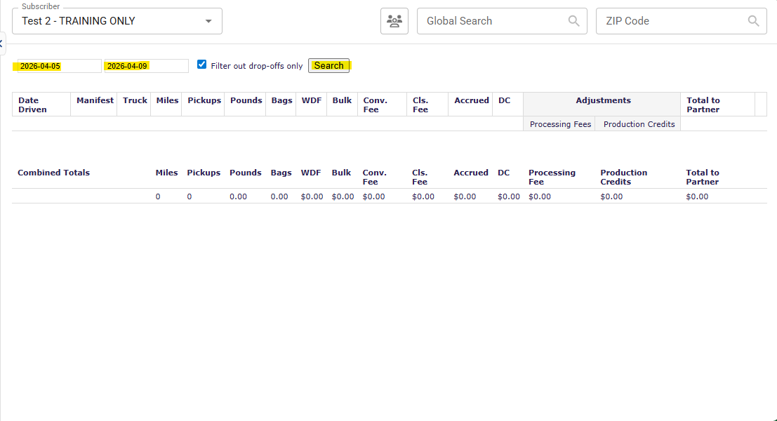
- Click “Show Details” 