How to Access Production Reports

- Click Reports on left side bar 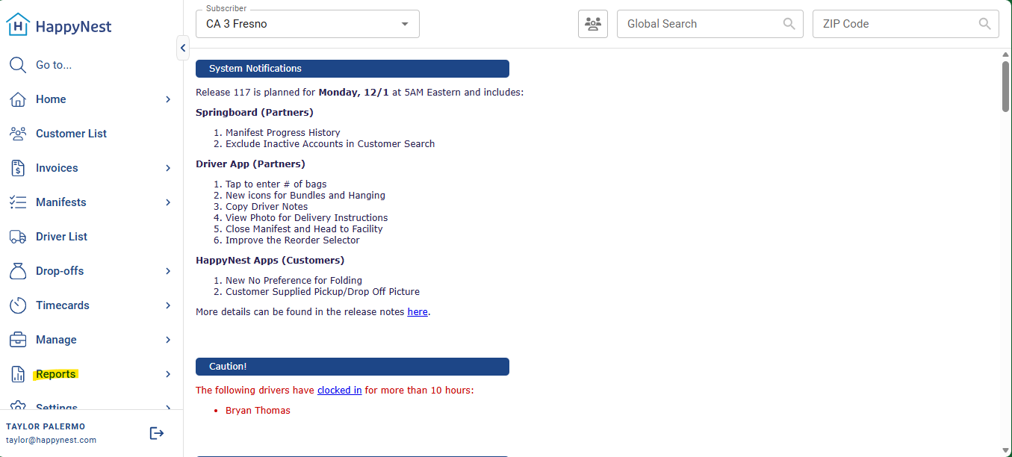

- Click Reports again 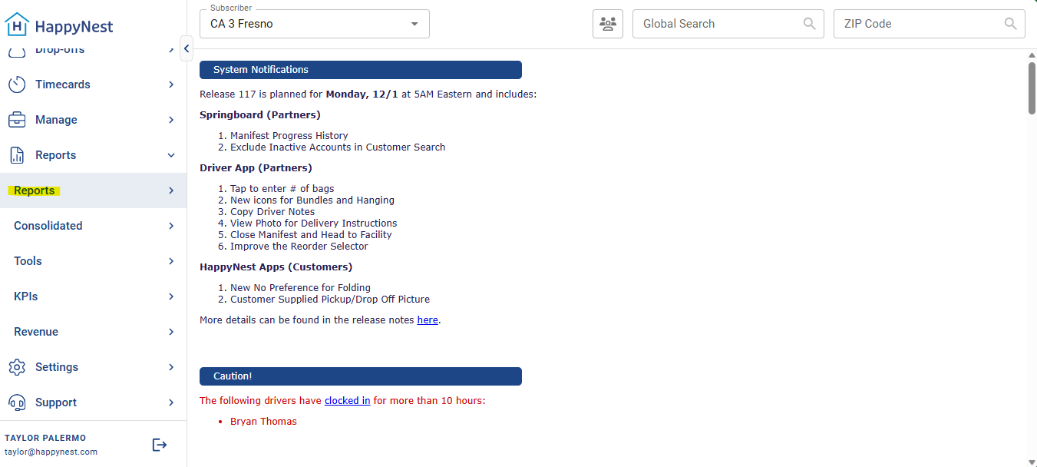
- Click Production and it will take you to the Production Report 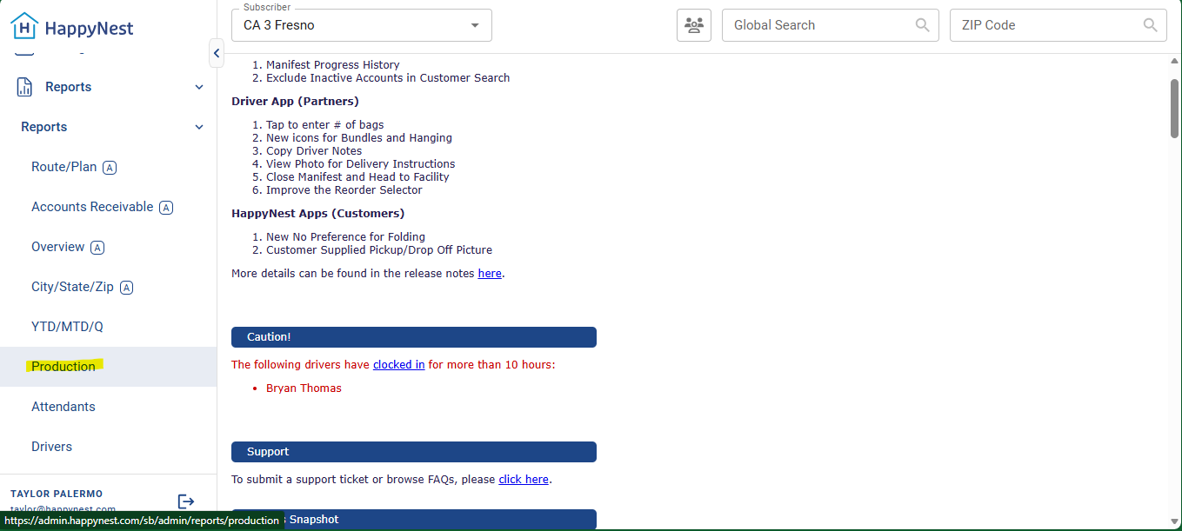

- From this page you can select the date range you wish to see, by timecard or by pickup date. 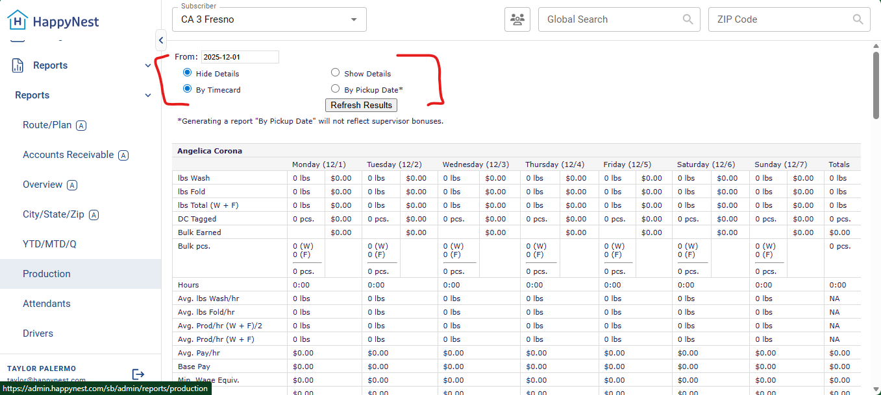

Whatever information you enter in these categories during User setup process will appear in the Driver/Attendant/Production reports on Springboard. Please note example below:
