How to Configure Your Zebra Printer Settings

- Click, “Zebra Utilities Setup” on your laptop/desktop home screen. Click “yes” on the next pop-up to allow the program to open.
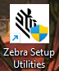
- Press, “configure printer settings” 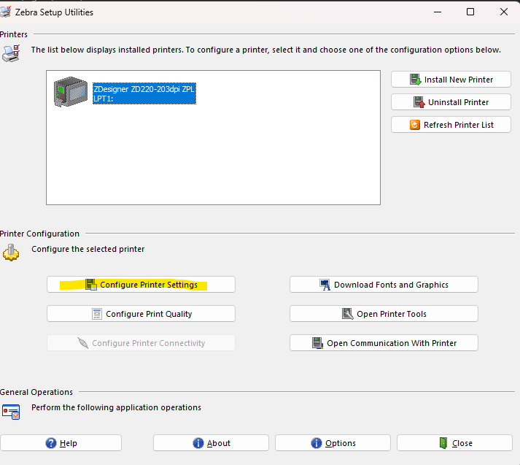
- Make sure the width is set to “4.00” and the height is set to “3.00” then press finish. 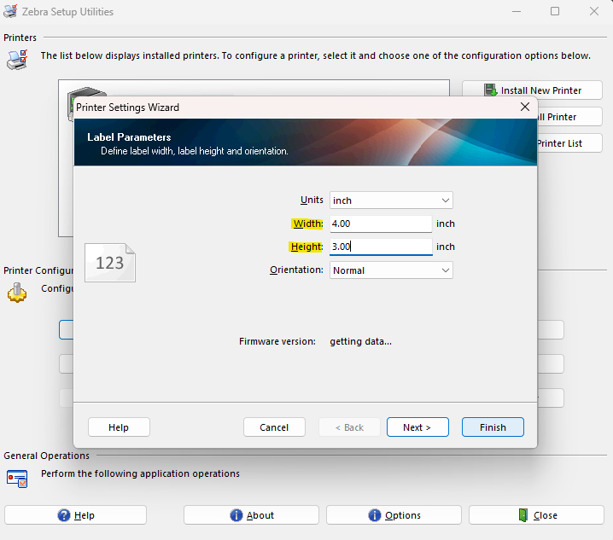

You can try and print a label now through Springboard and the label should fit properly! Please make sure to double click the “Zebra Browser Print” icon twice to run the program. This will not pull up a browser on the computer, but it is necessary to run the software for the printer. If you are experiencing any issues even after this process, please call Production Support at 401 567 1011.

